Ryan Marinelli

Question 3

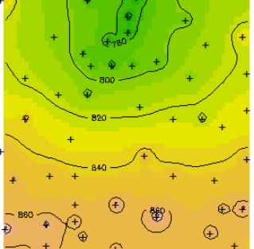

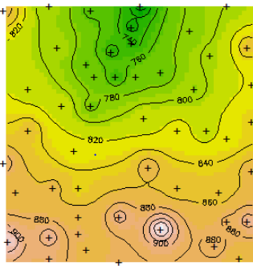

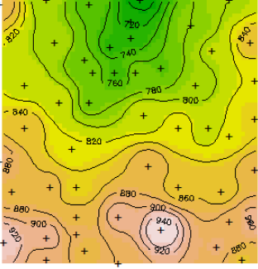

B.

I think the third map is the best. It appears to pick up on actually topographical features.

C.

In general, cross-validation should be able to be used to compare estimates here to reality. You would just have to break it into k-folds. It would seem ill advised to do LOOCV though, I suspect variance between autocorrelated would be too severe.

D.

There are assumption made when performing algorithms. For instance, have more exact knowledge of peaks would allow you to make more reasonable assumptions for height. Given these considerations, it would be possible to make conduct a more reliable procedure

E.

Having the description in the question allows us to be aware of some of the bias in the model. Given that the transformation to z might not be reasonable, because altitude likely varies significantly, the model probably isn’t great.

Question 4

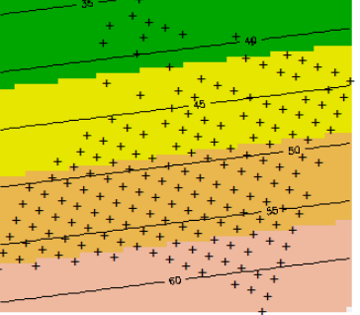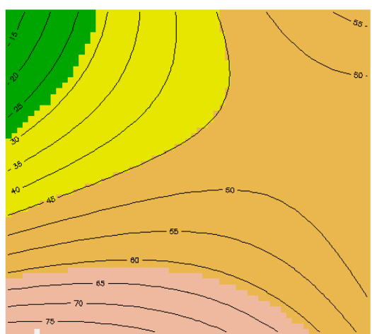

The relationship of the trend surface for calcium is approximately linear. Although there are some gains through using polynomial regression, it doubtful this is getting at a more initiate relationship with the data. It is more likely attempting to overfit the data with higher order regression methods. Given the distribution of the data, it is likely sufficient to keep a simple linear model. However, through looking at the points with a high peak, it suggests that a poisson regression model might be a better model.

Question 5

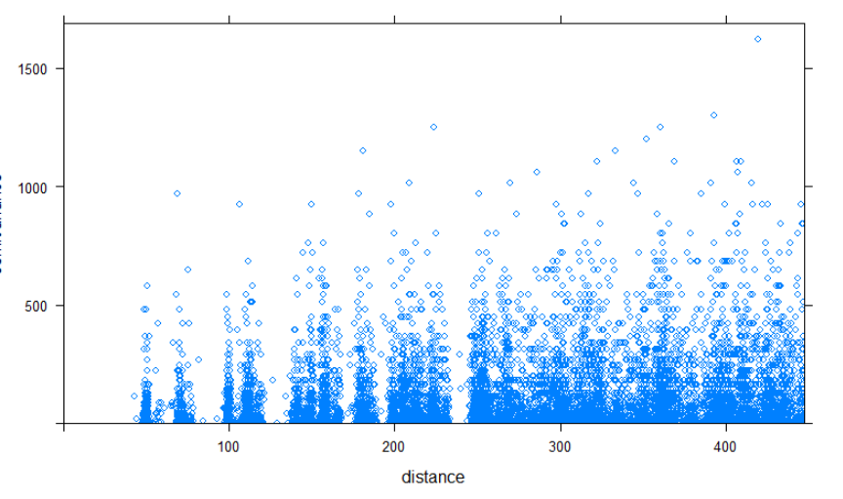

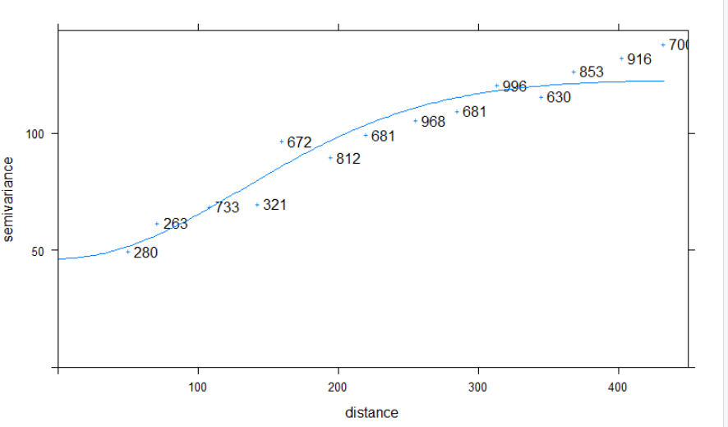

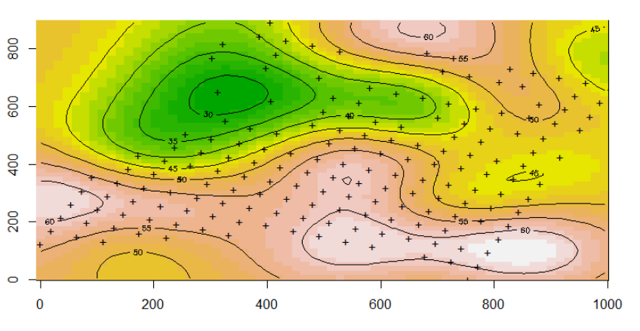

It appears that after 300 meters or so, there is little relationship calcium and distance. This break can be in seen in the experimental variogram cloud. As for the experimental variogram cloud, it appears to not be picking-up on this relationship.